Home Security System

Eng 405 Milestone 6

Shubin Yuan

Bob Jones University

Eng 305

Dr. Lovegrove

4/21/2023

# Introduction:

Based on my Design validation test plan Agreement I have 6 total criteria:

* + - Cost
    - Weight
    - Lock responding time
    - Running Memory Usage
    - Size
    - Sensor detects Accuracy

And here is its appearance:

# Test method

1. Cost

All required sections will be documented using excel. All data will be stored in the Eng 405 BoM file.

1. Weight

Using electronic scale OHAUS Scout Series Balance. From datasheet and result they provide in their website. The accuracy or MPE (maximum permissible error) of scale is 0.10%. where:

SD — standard deviation. N – Desired smallest net weight

|  |  |  |
| --- | --- | --- |
| **Balance's readability** | **d (g)** | **Optimum minimum weight (820d)** |
| 0,01mg | 0,00001 | 0,00820g |
| 0,1mg | 0,0001 | 0,0820g |
| 1mg | 0,001 | 0,820g |
| 0,01g | 0,01 | 8,20g |
| 0,1g | 0,1 | 82,0g |

1. Lock responding time

Two methods are used:

1. Test with stopwatch. Start at moment when the button clicked; stop at moment sound is heard.
2. Test with video recording, timer frame by frame.
3. Running Memory Usage
4. Use system memory to check its running memory check every 5 minute for 5 time with programming running on the front. Android Version 11
5. Use Phone Check and Test Version 9.5.1.
6. Size

Measure by metric ruler

1. Sensor detects Accuracy

Walk under sensor at least 100 times.

# Result, process and calculation

## Cost

From BoM file:

|  |  |  |  |  |  |  |  |
| --- | --- | --- | --- | --- | --- | --- | --- |
|  | **Product Cost [$]** | | **Mass** | |  | **Purchased** | |
| **Qty** | **Unit** | **Total** | **Unit [lb]** | **Total [lb]** |  | **Qty** | **Total Cost [$]** |
| 1 | 1.831666667 | 1.831666667 | 0.039625 | 0.039625 |  | 6 | 10.99 |
| 1 | 16.99 | 16.99 | 0.06 | 0.06 |  | 1 | 16.99 |
| 1 | 3.695 | 3.695 | 0.149375 | 0.149375 |  | 2 | 7.39 |
| 1 | 10.39 | 10.39 | 0.00775 | 0.00775 |  | 1 | 10.39 |
| 1 | 15.49 | 15.49 | 0.3625 | 0.3625 |  | 1 | 15.49 |
| 1 | 10.99 | 10.99 | 0.21875 | 0.21875 |  | 1 | 10.99 |
| 1 | 5.495 | 5.495 | 0.529375 | 0.529375 |  | 2 | 10.99 |
| 4 | 0.021159574 | 0.084638298 | 0.001 | 0.004 |  | 940 | 19.89 |

Total mass cost: $103.12

**Total product cost: $64.97**

All part is in the files include screws.

**Pass cost A level**

## Weight

桌子上摆放着黑色的机器

Test picture file: WeightT1.jpg, and WeightT2.jpg

By OHAUS Scout Series Balance ± 0.10%

|  |  |  |
| --- | --- | --- |
| Number of times | Result in g | Accuracy |
| 1 | 196.6 | ± 0.10% |
| 2 | 196.6 | ± 0.10% |
| 3 | 196.6 | ± 0.10% |
| 4 | 196.6 | ± 0.10% |
| 5 | 196.6 | ± 0.10% |

By another scale:

|  |  |
| --- | --- |
| Number of times | Result in kg |
| 1 | 0.200 |
| 2 | 0.200 |
| 3 | 0.195 |
| 4 | 0.196 |
| 5 | 0.195 |

To ensure accurate measurements, follow these steps for each of the 10 tests:

* Turn off the scale and wait for 1 minute to allow it to stabilize.
* Take 5 measurements using the OHAUS Scout Series Balance with an accuracy of ± 0.10%.
* Take 5 measurements using other scales with a similar accuracy.
* Record the result of each test in the format of X ± 0.10 g, using the same units of measurement for all tests.

The result from the OHAUS Scout Series Balance after taking 5 measurements is 196.6 ± 0.10 g, indicating high precision and reliability. These tests will help to ensure accurate measurements and identify any inconsistencies or errors in the scales used. For another scale: use standard deviation.

0.1970±0.0025 or 0.197±1.27%

Result of 10 data:

**196.9 g± 1.27% g**

**Pass Weight A Level**

## Lock responding time:

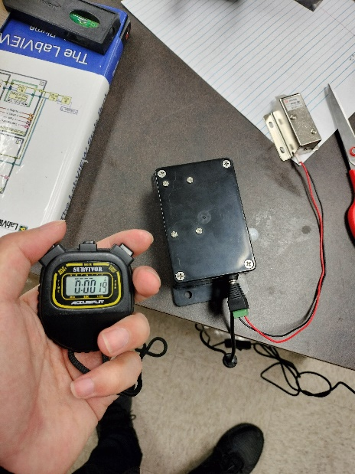

Relative Files: RespondT.jpg, RespondMP4.mp4

By Stopwatch:

|  |  |
| --- | --- |
| Time Case | s |
| 1 | 0.25 |
| 2 | 0.16 |
| 3 | 0.19 |
| 4 | 0.26 |
| 5 | 0.24 |

**Result: 0.22±0.043 or 0.22±19.5%**

By slow motion video:

|  |  |  |
| --- | --- | --- |
| Time Case | s | frame |
| 1 | 0.070 | 17 |
| 2 | 0.083 | 20 |
| 3 | 0.075 | 18 |
| 4 | 0.070 | 17 |
| 5 | 0.083 | 20 |

**Result: 0.0762±0.0065 or 0. 0762±8.53% s**

Since result have huge difference, I will not use standard deviation for this two. However Both of them:

**Pass responding time level A.**

## Running Memory Usage

In MB connected

|  |  |  |  |  |  |  |  |  |  |
| --- | --- | --- | --- | --- | --- | --- | --- | --- | --- |
| 6 | 6 | 7 | 5 | 5 | 4 | 6 | 4 | 6 | 3 |

In MB disconnected

|  |  |  |  |  |  |  |  |  |  |
| --- | --- | --- | --- | --- | --- | --- | --- | --- | --- |
| 4 | 3 | 5 | 6 | 5 | 5 | 6 | 4 | 6 | 7 |

As I used MIT App Inventor, I needed to store large amounts of libraries which consumed more MB of memory. However, since my connection and data sending processes had minimal effects on memory usage, I was able to manage the memory efficiently.

**Result: 5.15±** **1.18 or 5.15±0.22% MB**

If Arduino keeps sending data (if Arduino is broken keep sending data 32KB per second), the App will receive it to its maximum capacity and process it simultaneously. The app will crash with a maximum usage running memory 154MB. (Memory overwrite or Pipeline crash)

**Pass Running memory Usage Level A.**

## Size:

Measure by electronic ruler.

Length

|  |  |  |  |  |  |
| --- | --- | --- | --- | --- | --- |
| In mm | 98.53 | 98.34 | 99.30 | 98.64 | 99.17 |

Width

|  |  |  |  |  |  |
| --- | --- | --- | --- | --- | --- |
| In mm | 68.33 | 67.73 | 68.76 | 68.43 | 67.93 |

Hight

|  |  |  |  |  |  |
| --- | --- | --- | --- | --- | --- |
| In mm | 51.10 | 50.78 | 51.06 | 51.07 | 50.29 |

Length

**Result: 98.80 ± 0.42 or 98.80 ± 0.42% mm**

Width

**Result: 68.24 ± 0.40 or 68.24 ± 0.60% mm**

Hight

**Result: 50.86 ± 0.34 or 50.86 ± 0.68% mm**

**Pass Size Level A.**

## Sensor detects Accuracy

Relative file: Accuracy.MOV

With video record the process of passing through door and phone. Wait at least 5 second after every time I go through the door, In more than 100 times test, **the detection rate is 100%**

**Pass 6. Sensor detects Accuracy Level A.**

# Conclusion:

**Cost: $64.97. Pass A**

**Weight: 196.9 g± 1.27% g Pass A**

**Lock responding time:**

**By Stopwatch: 0.22s ± 0.043s or 0.22s ± 19.5%s Pass A**

**By video: 0.0762 s ± 0.0065 s or 0. 0762 s ± 8.53% s Pass A**

**Running Memory Usage: 5.15 MB ± 1.18 MB or 5.15 MB ±0.22% MB Pass A**

**Size:**

**Length: 98.80 mm ± 0.42 mm or 98.80 mm ± 0.42% mm Pass A**

**Width: 68.24 mm ± 0.40 mm or 68.24 mm ± 0.60% mm Pass A**

**Hight: 50.86 mm ± 0.34 mm or 50.86 mm ± 0.68% mm Pass A**

**Sensor detects Accuracy: 100% Pass A**